Book

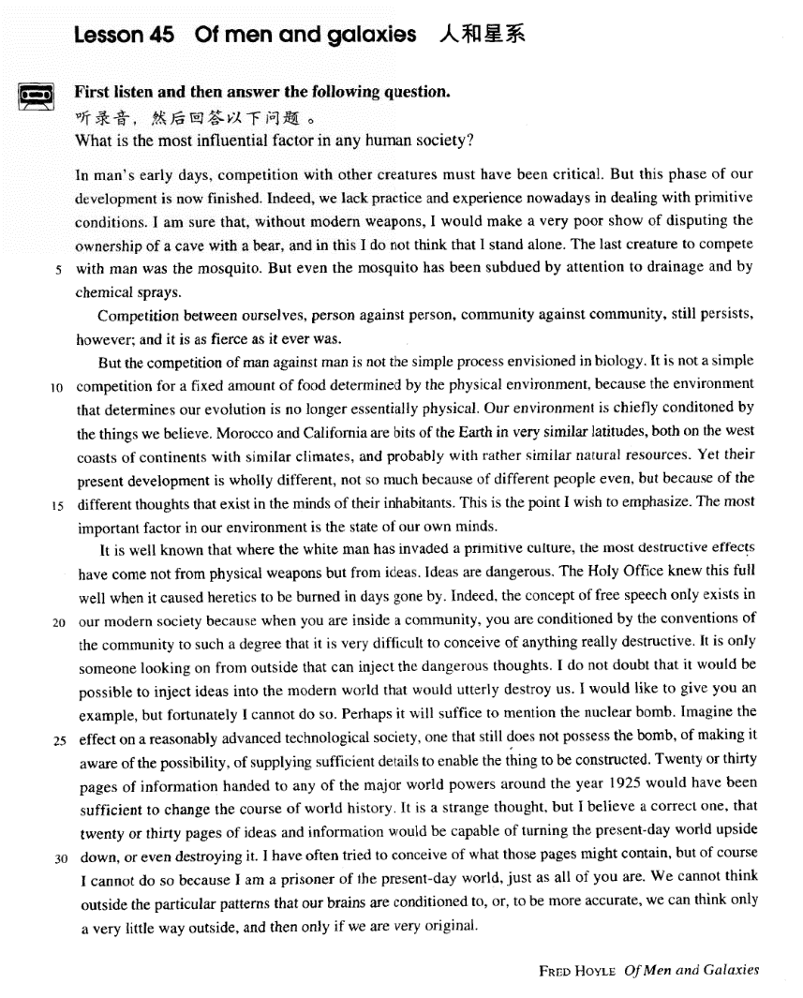

课文

In man's early days, competition with other creatures must have been critical.

在人类早期，人类与其他生物的竞争一定是必不可少的。

But this phase of our development is now finished.

但这个发展阶段已经结束。

Indeed, we lack practice and experience nowadays in dealing with primitive conditions.

确实，我们今天缺乏对付原始环境的实践和经验。

I am sure that, without modern weapons, I would make a very poor show of disputing the ownership of a cave with a bear, and in this I do not think that I stand alone.

我断定，如果没有现代化的武器，要我和一只熊去争洞穴，我会出洋相的；我也相信，出洋相者并非我一人。

The last creature to compete with man was the mosquito.

能与竞争的生物最后只有蚊子，

But even the mosquito has been subdued by attention to drainage and by chemical sprays.

然而即使蚊子，也由于我们注意清理污水和喷洒化学药品就被制服了。

Competition between ourselves, person against person, community against community, still persists, however; and it is as fierce as it ever was.

然而人类之间的战争，人与人，团体与团体，依然在进行着，而且和以前一样激烈。

But the competition of man against man is not the simple process envisioned in biology.

但是，人与人的竞争并不像生物生物学中想像的那样是一个简单过程。

It is not a simple competition for a fixed amount of food determined by the physical environment, because the environment that determines our evolution is no longer essentially physical.

它已不是为争得物质环境所决定的东西所决定。

Our environment is chiefly conditoned by the things we believe.

我们的环境主要是由我们所相信的东西所决定。

Morocco and California are bits of the Earth in very similar latitudes,

摩洛哥和加利福尼亚是地球上纬度极其相似的两个地方，

both on the west coasts of continents with similar climates, and probably with rather similar natural resources.

都在各自大陆的西海岸，气候相似，自然资源也可能相似。

Yet their present development is wholly different,

但是，这两个地方目前的发展程度完全不一样。

not so much because of different people even, but because of the different thoughts that exist in the minds of their inhabitants.

这倒不是因为人民不同，而是由于居民头脑中的思想不同。这是我要强调的论点。我们环境中最重要的因素就是我们的思想状况。

This is the point I wish to emphasize. The most important factor in our environment is the state of our own minds. It is well known that where the white man has invaded a primitive culture, the most destructive effects have come not from physical weapons but from ideas.

众所周知，凡是白人侵入原始文化的地方，破坏作用最大的不是杀人的武器，而是思想。思想是危险的。宗教法庭对此是非常清楚的，因此从前它总是把异教徒烧死。

Ideas are dangerous. The Holy Office knew this full well when it caused heretics to be burned in days gone by. Indeed, the concept of free speech only exists in our modern society because when you are inside a community, you are conditioned by the conventions of the community to such a degree that it is very difficult to conceive of anything really destructive.

的确，言论自由的概念只存在于我们现代社会中，因为当你生活在一个社团中时，社团的风俗习惯会严格地制约你，使你很难有破坏性的想法。

It is only someone looking on from outside that can inject the dangerous thoughts.

只有外部的旁观者才能灌输危险的思想。

I do not doubt that it would be possible to inject ideas into the modern world that would utterly destroy us.

向现代世界灌输一种思想以便摧毁我们人类是可能的事，对此我并不怀疑。

I would like to give you an example, but fortunately I cannot do so.

我愿为你举个例子，但幸亏我举不出。

Perhaps it will suffice to mention the nuclear bomb.

也许提一下核弹就足以证明了。

Imagine the effect on a reasonably advanced technological society, one that still does not possess the bomb, of making it aware of the possibility, of supplying suffcient details to enable the thing to be constructed. Twenty or thirty pages of information handed to any of the major world powers around the year 1925, would have been sufficient to change the course of world history.

对一个沿未拥有核弹、但科技相当发达的社会，如果告诉它制造核弹的可能性，而且向它提供制造核弹的细节，那么可以设想，这将对这个社会产生何等的影响。如果把二三十页的情报交给1952年前后的任何一个世界强国，就足以改变世界历史的进程。二三十页材料中的思想和情报会便当今的世界翻天覆地，甚至毁灭这个世界。

It is a strange thought, but I believe a correct one, that 20 or 30 pages of ideas and information would be capable of turning the present-day world upside down, or even destroying it. I have often tried to conceive of what those pages might contain, but of course I cannot do so because I am a prisoner of the present-day world, just as all of you are. We cannot think outside the particular patterns that our brains are conditioned to, or,

这是个离奇的想法。不过我认为这个想法是正确的。我常常试图想像这些纸上所写的东西，不过我是做不到的，因为我和你们大家一样，是当今世界上的凡人。我闪不能脱离我们大脑所限定的模式去问题，

to be more accurate we can think only a very little way outside and then only if we are very original.

我们只能稍微离开一点儿，就这也需要我们独创的思想。

词汇讲解

Lesson 45 Of men and galaxies

v. 争夺，捍卫；争论，争执；质疑

dispute v. 1. to fight to get control of sth. or to win sth. 争夺，捍卫

Our soldiers disputed every inch of ground.

On the last lap three runners were disputing the lead.

I am sure that, without modern weapons, I would make a very poor show of disputing the ownership of a cave with a bear, and in this I do not think that I stand alone.

dispute v. 2. to argue or disagree with sb. 争论，争执

The issue remains hotly disputed.

They disputed at great length what they should do.

dispute v. 3. to question whether sth. is true and valid 质疑

These figures have been disputed. The election result was disputed.

Galileo maintained that the earth revolved around the sun, disputing the belief held by the Roman Catholic church that the earth was the center of the universe.

dispute n. a serious argument or disagreement 争议，争执，纠纷

be beyond dispute

China’s claims of sovereignty over the Diaoyu Islands are beyond dispute.

be open to dispute / question / debate

……尚有争议

It’s open to dispute / question / debate whether the new government is any better than the old one.

subdue [səb'dju:]

v. 征服，制伏，击败

subdue v. to defeat or control a person or group, esp. using force 征服， 制伏，击败

Police managed to subdue the angry crowd.

It is related of Caesar that when speaking of the ease with which he subdued Egypt, he made use of the laconic saying, ‘I came, I saw, I conquered.’

“duct” / “duce” / “due” = lead

subdue “sub” = under v. 征服，制伏，击败abduct “ab” = away v. 诱拐，绑架abduction n. 诱拐，绑架

abductor n. 绑匪

deduce “de” = down v. 推理，演绎deductive adj. 演绎的，推断的deduction n. 推理，演绎；结论

induce “in” = into v. 诱使，引起，造成

inductive adj. 归纳的

induction n. 归纳法；诱导；引发

introduce “intro” = inward v. 介绍，引进

produce “pro” = forward v. 生产，制造；产生，引起

reduce “re” = back v. 减少

seduce “se” = apart v. 色诱，勾引

seduction n. 色诱，勾引

traduce “tra” / “trans” = across v. 诋毁

conduct “con” = together v. 领导，指导；指挥 n. 行为，品德

viaduct “via” = road n. 高架桥ventiduct “venti” = wind n. 通风管oviduct “ovi” = egg n. 输卵管envision [ɪn'vɪʒn]

v. 设想，想象

envision v. to imagine what a situation will be like in the future = envisage = imagine 设想，想象

They envision an equal society, free of poverty and disease.

Nobody can envisage the consequences of total nuclear war.

But the competition of man against man is not the simple process envisioned in biology.

forecast v. & n.（公开地）预测，预报

weather forecast

the company’s annual sales forecast Rain has been forecast for tomorrow.

The Federal Reserve Bank forecasts the economy will grow 8% this year. predict / foretell v. 预言；foretell 预示

He predicted / foretold that the improvement will continue.

Timely snow foretells a bumper harvest. forebode v. 预示（不好的事情）

Black clouds forebode a storm.

prophesy v. 预言（尤指靠魔力或神力）

Jesus prophesied that one of his disciples would betray him. heretic ['herətɪk]

n. 异教徒；异端邪说者

heretic n. 1. a person who belongs to a particular religion, but whose beliefs or actions seriously disagree with the principles of that religion 异教徒

Thousands of heretics were burned at the stake.

heretic n. 2. someone whose beliefs or actions are considered wrong by most people, because they disagree with beliefs that are generally accepted 异端邪说者

He was considered a heretic and was ridiculed for his ideas.

heresy n. 1. a belief that disagrees with the official principles of a particular religion 异教观念

He was executed for heresy.

heresy n. 2. a belief, statement etc. that disagrees with what a group of people believe to be right 异端邪说

Radical remarks like this amount to heresy for most members of the

Republican party.

be heresy to sb.

The idea is heresy to most employees of the firm.

And perhaps all those successful college graduates would have been successful whether they had gone to college or not. This is heresy to those of us who have been brought up to believe that if a little schooling is good, more has to be much better.

suffice [sə'faɪs]

v. 足够

suffice v. (fml.) to be enough 足够

Generally a brief note or a phone call will suffice. suffice for sth.

Will $10 suffice for the trip? suffice to do sth.

One example will suffice to illustrate the point. Perhaps it will suffice to mention the nuclear bomb. suffice (it) to say (that) 只须说……就够了

I won't go into all the depressing details; suffice it to say that the whole

affair was an utter disaster.

*In man’s early days*, competition *with other creatures* must have been

critical.

these days in those days

In the pioneering days, however, this was not the case at all.

In the early days of the settlement of Australia, enterprising settlers unwisely introduced the European rabbit.

critical adj. very important 重大的，关键的

Practice is a critical factor in learning English.

Financial support is critical to the region’s development. But this phase *of our development* is now finished.

Arthur C. Clark once suggested a revolutionary idea passes through three phases: …

Indeed, we lack practice and experience *nowadays* in dealing with

primitive conditions.

indeed adv. used to introduce an additional statement that emphasizes or supports what you have just said 事实上

I didn't mind at all. Indeed, I was pleased.

It would be difficult. Indeed it would be almost impossible.

I am sure that, *without modern weapons*, I would make a very poor show *of disputing the ownership of a cave with a bear*, and in this I do not think that I stand alone.

Without something of this kind, searching for intelligences on other planets would be like trying to meet a friend in London without a

pre-arranged rendezvous and absurdly wandering the streets in the hope of a chance encounter.

make a very poor show 出洋相

make a fool / an exhibition of oneself

stand alone: to be in a position or place where there are no other people

孤立

On this issue, Britain stands alone against the US.

So long as we stand together（团结一致）, we’ll win. Don’t stand there（袖手旁观）—give me a hand!

He’ll be standing down（引退，退位）as CEO at the end of the year. She is going to stand trial（受审） for tax evasion.

No one is taller than those who are willing to stand corrected（接受他人指正）.

The Tibetans call it Chomulungma, “Goddess Mother of the Snows”. *Goddess Mother of the world, actually. In the traditional Tibetan translation.*

I stand corrected.

There is no need to stand on ceremony（拘于礼节，拘谨）—come in and relax.

If you want to go abroad, we won’t stand in your way（阻拦你）. The last creature *to compete with man* was the mosquito.

But even the mosquito has been subdued *by attention to drainage and by*

*chemical sprays*.

drainage 1. [U] process by which water or liquid waste is drained from an area 排水

a drainage system

drainage facilities

drainage 2. [U] a system of drains 排水系统

The drainage of the city is not good: some of the pipes are broken.

spray n. liquid which is forced out of a special container in a stream of very small drops 喷雾

a new hair styling spray

Most farmers use pesticide sprays.

Competition between ourselves, *person against person, community*

*against community*, still persists, however; and it is as fierce as it ever was.

persist v. 1. if something bad persists, it continues to exist or happen（坏事）持续

If the pain persists, consult a doctor.

The belief that the earth was flat persisted for many centuries.

persist v. 2. continue doing sth. in a determined but often unreasonable

way 执意做某事

persist in doing sth.

If he persists in asking awkward questions, then send him to the boss.

She was sentimentally attached to this house, for even though it was far too big for her needs, she persisted in living there long after her husband's death.

fierce adj. involving a lot of force or energy（竞争等）激烈的

We face fierce competition from overseas competitors. There was a fierce opposition of the proposal.

But the competition *of man against man* is not the simple process envisioned in biology.

It is not a simple competition *for a fixed amount of food determined by*

*the physical environment*, because the environment that determines our

evolution is no longer essentially physical. competition for sth.

Competition for the job was intense.

We're in competition with several other companies for the contract.

fixed adj. fixed times, amounts, meanings etc. cannot be changed 固定不变的

a fixed price

The contract is for a fixed period of three years.

The interest rate on the loan is fixed.

physical adj. connected with things that actually exist or are present and can be seen, felt, etc. rather than things that only exist in a person‘s mind 物质的，实实在在的，真实而具体的，看得见摸得着的

the physical world / environment

physical weapons

Is there any physical evidence to suggest that a crime has been committed?

Our environment is chiefly conditioned by the things we believe. condition v. have an important effect on sb. / sth., determine 对……有重要影响，决定

be conditioned by …

We are all conditioned by the society and age we live in. What I buy is conditioned by the amount I earn.

Morocco and California are bits of the Earth in very similar latitudes, both on the west coasts of continents *with similar climates, and probably*

*with rather similar natural resources*.

latitudes n. [pl] an area at a particular latitude 纬度地区

in … latitudes

The birds breed in northern latitudes. The plant grows best in cooler latitudes.

a town on the south coast of England

a thriving holiday resort on the east coast of Italy.

Yet their present development is wholly different, not so much because of different people even, but because of the different thoughts that exist in

the minds of their inhabitants.

Yet their present development is wholly different, not so much because of different people even, but because of the different thoughts that exist in the minds of their inhabitants.

然而，它们目前的发展程度完全不同，甚至可以这样说：这与其说是

因为人的区别，不如说是因为居民头脑中思想观念的区别。

not so much … as … 与其说是……不如说是…… She's not so much poor as careless with money.

The details are not so much wrong as they are incomplete. The holidays ended all too soon.

假期结束得实在是太快了。

I’m only too ready to help you. 我实在是非常乐意帮助您。 I did so see him.

我确实看到他了。

No, I won’t help you, so there?

不，我不想帮助你，你拿我怎么样？

This is the point I wish to emphasize.

wish to do sth. (fml.) = want to do sth. = like to do sth. She wishes to be alone.

I wish to make a complaint.

The most important factor *in our environment* is the state *of our own*

*minds*.

It is well known that where the white man has invaded a primitive culture, the most destructive effects have come *not* from physical weapons *but*

from ideas.

man n. a person, either male or female ―used esp. in formal situations or in the past 人

All men are equal in the eyes of the law.

Growing old is something a man has to accept.

come from / of (doing) sth.: be the result of sth. 因为，是……的结果， 来自于

His air of confidence came from his firm belief that he was the best candidate for the job.

It's the kind of accident that comes from being careless. I did ask a few questions, but nothing came of it.

That comes of eating too much!

That's what comes of not practicing ― you've forgotten everything!

Ideas are dangerous. The Holy Office knew this *full well* when it caused heretics to be burned *in days gone by*.

the Inquisition / Holy Office 宗教法庭

a Roman Catholic organization in the past whose aim was to find and punish people who had unacceptable beliefs

In his own lifetime Galileo was the centre of violent controversy; but the scientific dust has long since settled, and today we can see even his famous clash with the Inquisition in something like its proper perspective. know sth. full well / very well / perfectly well 非常清楚……

Preachers pray for rain, knowing full well that no such prayer was ever

answered.

You know very well what I'm talking about! I knew perfectly well it was a trap.

cause v. to compel by command, authority, or force 逼迫，迫使

cause sb. to do sth.

The king caused him to resign.

The moderator invoked a rule causing the debate to be ended. in days / times / years gone by = in the past

In times gone by, all crops were harvested by hand.

These herbs would have been grown for medicinal purposes in days gone by.

let bygones be bygones: to forget sth. bad that someone has done to you and forgive them 不计前嫌，既往不咎

Indeed, the concept of free speech only exists in our modern society

because when you are inside a community, you are conditioned by the conventions of the community to such a degree *that it is very difficult to*

*conceive of anything really destructive*.

free speech = freedom of speech n. the right to express any opinion in public without censorship or restraint by the government 言论自由

to such a degree / extent that …

Her condition deteriorated to such a degree that a blood transfusion was considered necessary.

It is a harmless habit, but it litters up her desk to such an extent that every time she opens it, loose bits of paper fall out in every direction.

conceive v. (fml.) to imagine a particular situation or to think about something in a particular way 想象，设想

conceive of sth.

Many people can't conceive of a dinner without meat or fish.

It is only someone looking on from outside that can inject the dangerous thoughts.

look on = stand by 旁观

Only one man tried to help us, the rest just looked on / stood by in silence.

onlooker = bystander 旁观者

look on … as … 把……看做…… We look on her as a daughter. stand by sb. 支持帮助某人

He stood by her through the difficult times.

inject v. to add something new to a situation 注入…… Young staff are injecting new life into the company.

Try to inject confidence into your voice.

I do not doubt that it would be possible to inject ideas into the modern

world *that would utterly destroy us*.

You may pick them up in utter exhaustion, if wind over the sea has driven them to a long journey.

I would like to give you an example, but fortunately I cannot do so. Perhaps it will suffice *to mention the nuclear bomb*.

Imagine the effect on a reasonably advanced technological society, one that still does not possess the bomb, *of making it aware of the possibility*, *of supplying sufficient details to enable the thing to be constructed*. reasonably adv. 1. in a reasonable way 合理地，合乎逻辑地

discuss the matter calmly and reasonably

reasonably 2. to a fairly high degree, level, or standard = fairly 相当地， 颇为

reasonably good / accurate / clear

We are reasonably sure this is the best solution. the effect / influence / impact of … on / upon … the influence of parents on their children

the effect of fertilizers on the crops

the impact of the oil spill on marine life

In the organization of industrial life the influence of the factory upon the physiological and mental state of the workers has been completely neglected.

This result merely confirms earlier American and British studies: if there is any effect of noise upon mental health, it must be so small that present methods of psychiatric diagnosis cannot find it.

Snakes did not acquire their poison for use against man but for use against prey such as rats and mice, and the effects on these of viperine poison is almost immediate.

Twenty or thirty pages of information *handed to any of the major world powers around the year 1925* would have been sufficient *to change the*

*course of world history*.

power n. a country that is strong and important and can influence events,

or that has a lot of military strength 大国， 强国

Egypt is still a major power in the Middle East.

Zheng He’s seven expeditions established China as the world’s top naval power.

superpower n. any of the most powerful nations in the world, esp. the USA or former USSR 超级大国

Since the disintegration of the USSR, there has been only one

superpower ― the USA.

If twenty or thirty pages of information had been handed to any of the major world powers around the year 1925, it would have been sufficient to change the course of world history.

If twenty or thirty pages of information had been handed to any of the major world powers around the year 1925, the course of world history would have been changed.

Had twenty or thirty pages of information been handed to any of the major world powers around the year 1925, it would have been sufficient to change the course of world history.

Had twenty or thirty pages of information been handed to any of the major world powers around the year 1925, the course of world history would have been changed.

be sufficient to do sth.

The money is not sufficient to cover everything that needs doing.

It is a strange thought, but *I believe* a correct one, that twenty or thirty pages of ideas and information would be capable of turning the present-day world upside down, or even destroying it.

present-day adj. existing now 当今的

The amount of money is small by present-day standards. The novel is set in present-day Russia.

upside down adv. with the top at the bottom and the bottom at the top 颠

倒，翻转

To get the plant out of the pot, turn it upside down and give it a gentle knock.

upside-down adj. with the upper part underneath instead of on top 上 下

翻转过来（的）

That picture is upside-down.

I have often tried to conceive of what those pages might contain, but of course I cannot do so because I am a prisoner of the present-day world, *just as all of you are*.

We cannot think outside the particular patterns that our brains are conditioned to, or, *to be more accurate*, we can think only a very little way outside, and then *only if we are very original*.

condition v. 1. have an important effect on sb. / sth., determine 对……有

重要影响，决定

condition v. 2. to train or influence a person or animal mentally so that they do or expect a particular thing without thinking about it 训练或影响……使习惯或适应……

condition sb. to do sth.

Pavlov conditioned dogs to salivate at the sound of a bell.

Many women are conditioned from birth to be accepting rather than questioning.

condition sb. to sth.

It didn't take them long to become conditioned to the new environment. Patients can become conditioned to particular forms of treatment. conditioning n. 潜移默化的影响

Conditioning starts as soon as boys are given guns to play with and girls

are given dolls.

Social conditioning makes crying more difficult for men.

After years of conditioning, most of us have developed an unshakable faith in railway time-tables.

then adv. used to add sth. to what you have just mentioned 此外，而且

and then

It costs $20, and then there's the sales tax to pay.

We have to invite your parents and my parents, and then there's your

brother.

only if …: 只有……

The missiles can be fired only if the operator types in a six-digit code.

If you are younger, and in a solid financial position, you may decide to take an aggressive approach, but only if you're blessed with a sanguine disposition and won't suffer sleepless nights over share prices.

she will go only if he goes. Only if he goes *will* she go.

original adj. able to produce new ideas, creative 有创见的，有创造力的

an original thinker / writer / painter

the product of a highly original mind